Aleksandrs Lukjanovs (M00674847)

Individual Project CST3990

**Immersive and Affordable Force Feedback Haptic Glove Project**

# Introduction

Haptic gloves are not a new concept while not well know they have been in development as far back as 1977. They aim to improve over a traditional controller by offering improved immersion, haptic feedback, more natural movement and representation of fingers.

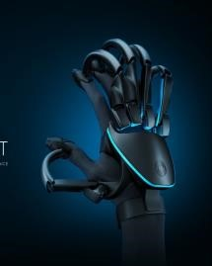

Examples of popular controllers:

* Oculus Quest Controllers (Figure 1): Currently Facebook or Meta produces the most popular VR headset on the market today. Part of the headset are the controllers that offer:

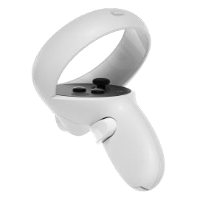

*Figure*

*1*

* 1. Very sensitive buttons that with the slightest application of force will move your fingers. The headset uses assumption based on these sensors to position your fingers.
  2. Controllers come with a gyroscope and an accelerometer to help with predicting where your hands are in the real life so that it can be translated into the virtual environment.
  3. Additional buttons and a joystick for extra actions such as walking or interaction.

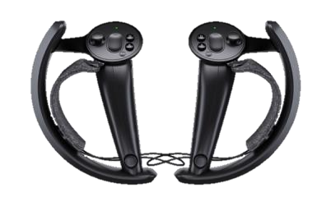

* Valve Index Controllers (Figure 2): Valve produces the Valve Index and it’s accompanying controllers come with:

* 1. Very sensitive buttons that with the slightest application of force will move your fingers. Only for your index and

thumb fingers. *Figure 2*

* 1. Controllers come with a gyroscope and an accelerometer to help with predicting where your hands are in the real life so that it can be translated into the virtual environment.
  2. Additional buttons and joystick for extra actions such as walking or interaction.
  3. Index controllers also come with sensors in the handle to more accurately track all your fingers. Those sensors can detect what your fingers position is when they are close enough and predict where they are if they are outside range.

* Vive Pro2 Controllers (Figure 3): Vive produces the Vive Pro 2 headset and it’s accompanying controllers come with:

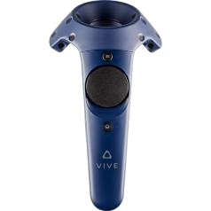

*Figure*

*3*

* 1. Very sensitive buttons that with the slightest application of force will move your fingers.
  2. Controllers come with a gyroscope and an accelerometer to help with predicting where

your hands are in the real life so that it can be translated into the virtual environment.

* 1. Additional buttons and a trackpad for extra actions such as walking or interaction.

|  |  |  |  |
| --- | --- | --- | --- |
| **Name** | Oculus Quest Control-  ler | Valve Index Controller | Vive Pro2 Controller |
| **Sensitive Buttons** | Yes | Yes | Yes |
| **Joy Stick** | Yes | Yes | No |
| **Track Pad** | No | Yes | Yes |
| **Gyro** | Yes | Yes | Yes |
| **Accelerometer** | Yes | Yes | Yes |
| **Finger Tracking** | Headset | Controller | No |
| **Price** | £60.00 | £ 131.25 | £170.00 |

These controllers give you a way to interact with the game environment however, they are limited by their form factor and by design they follow an old theme of a controller invented way back in the age of Atari in 1977. The whole point of a haptic glove is to be a more natural way and immersive way to interact with the game environment.

In my project I will improve over the oculus quest controller specifically as the oculus quest headset is the most popular on steam as suggested by Techradar (Wood, 2021) and I have access to their controllers. I will improve over the oculus quest controller by creating a haptic-glove that provides a more natural, and immersive way to interact with the game environment over these controllers. My haptic glove will achieve this by providing haptic-feedback that is more accurate, providing accurate finger tracking in relation to your real hand, and still remain very accurate. The condition for the project is that it has to be as cheap as possible.

**Objectives:**

* Create an exoskeleton which is able to prevent finger movement to simulate collision of your fingers in real life with an object improving immersion over the oculus quest controller.
* Use micro motors and controlled precise electro shocks to simulate sensation of touch and improve sensation accuracy over just a single vibrating motor in the oculus quest controller.
* Improve hand tracking so your hand can be more accurately represented in the 3D VR space compared to oculus quest controllers’ sensitive buttons.
* Investigate methods of cost reduction in the production environment.

**Deliverables:**

* Project Proposal
* Literature Review/ Progress Report
* Haptic Glove
* Testing Environment (Interactive game for the glove.)
* Final Report and Evaluation

# Literature Review

There are various people and teams that worked on haptic gloves prior to me attempting my project. The haptic gloves produced by said teams and people have varied applications but commonly all teams aim to create a more immersive way for a human to interact with an object.

**Research papers on the subject:**

1. What the work is about.
2. Unique parts of the work.
3. Why and what you will use something and why its a good idea or why you will not use it and why its a bad idea.
4. Overall Conclusion of what you will use.

* **Wang et al.,(2020)** have researched a force feedback data glove for their virtual training system. Their design is composed of three modules: Integrated data glove module, data interface adaptation and virtual scene module. Their haptic glove primary functions are to allow for spatial positioning, action capture, and force feedback. The haptic glove is connected to a data interface adaptation module that mainly does noise filtering, data formatting and data transmission the type of data it deals with is raw data about the palm position, altitude, and finger position. The information processed is shared between the data interface adaptation module and the virtual scene module which reproduces the players hand in the virtual space based on the real one. Similarly, if the virtual hand experiences resistance so will the real one due to the force feedback.

This paper addresses primarily the issues of positioning, finger curvature and the overall underlying structure of the glove. For positioning since I am using an oculus quest headset with their unreal engine I will use the controllers for positioning which already do the calculations. As for the finger curvature of my gloves my 5 encoders can reasonably well predict the curvature based on the cable length. The system structure however sounds very reasonable and applicable to my design as I have a similar layout of parts. I have the main haptic glove with it’s modules which send information to the Arduino. The Arduino controls the haptic modules and sends data to the virtual environment just like their diagram.

* **Zykov, Shigapov, Kugurakova, (2018)** have created a research paper that discusses different designs of haptic gloves and explores a design of a ‘good’ haptic glove design. The paper provides examples of various digital gloves such as GloveOne, CaptoGlove, Manus VR, Senso, Noitom Hi5 VR, VRfree, HaptX which it uses as examples of current standards. According to this paper a good haptic glove be low cost, light weight, ungrounded, while still providing force feedback that realistically stimulates touching and manipulating virtual objects. It also expects the glove to be sturdy enough to resist a lot of force from fingers and account for the metacarpophalangeal joint. Then the research paper presents it’s own idea for a haptic glove complete with an electronic implementation notes. It finalizes with it’s future works which has an extensive list of interesting improvements.

The current design that the paper suggests that the Arduino is used as the controller which I agree with due to the low cost, low profile and good performance nature of it. It’s also has a lot of sources material for it. I then agree with the use of vibration motors on fingers to help support the sensation of touch as they are too relatively low cost but add a lot to the immersion. Specifically, the coin button type phone vibrating motors are good for this job due to being compact and cheap. I do not however agree with the use of Bluetooth as it causes a lot more bulk to the glove and significantly adds to the cost due to the need for a powerful power pack likely at least Li-Po batteries at around 5V 5A. Finally, the paper concludes the design with future improvements, I will implement the force-feedback, finger calibration, and movement of the glove in

3D space due to the fact that I am using an oculus quest controller as my

portable gyro, accelerometer and rig for transmitting position information in the X-Y-Z axis to the headset.

The result of this research paper is that they have presented a good starting point to their path to a ‘good’ haptic glove which is a all in one package. I can use their idea of a number of small vibrating motors, use of Arduino, and sensors in between fingers. I will also implement some of their future ideas being force-feedback, finger calibration, and movement of the glove in 3D space.

- **Nozaki et al., (2007)** have created a research paper proposing a design of a cheap and safe force feedback haptic glove with varied uses. It does not aim to be extremely precise. It describes an improvement to their already existing design of glove. Both prototypes are similar in terms of functionality however one is far more polished version of the other. The newer haptic glove has a list of features such as:

1. The haptic glove was constructed around a working glove made from polyurethane fibre, they have stitched, glued and reinforced parts with velcro.

1. Passive electromagnetic brakes are used to stop the fingers making this glove safe as it does not actually pull back the string with anything more dangerous than just a spring.

1. Potentiometers were installed to measure the bending angles or length of the cable.

1. Bending sensors were installed to also measure the bending angles.

1. Sheet type force sensors were installed at the finger tips to measure the applied force applied.

Construction of a haptic glove made around the polyurethane fibre glove did make it easier however it made it harder to deal with long term problems sych as glove damage and hygiene and it made the haptic glove in general very limiting in terms of sizing. Not to mention that some parts will be harder to swap as you will need to damage the glove to take them off. The use of passive electromagnetic brakes made the glove really bulky and consumed a lot of power that is why I will use servos. The use of force sensors on the finger tips and bending sensors for extra precision is a good idea for a more immersive experience and they add little weight or cost. The use of pots seems unnecessary as they have bending sensors but extra information allows for verification of data. Also, it adds more precision. The use of resin on the cables, guide tubes, and distribution of force all are good ideas that I can use as that generally makes the glove better at no cost or downside.

* **Hosseini et al., (2018)** The paper here presents a design of haptic glove that is according to the writer is attempting to be light weight, less invasive, ergonomic while being affordable. The glove design here takes advantage of several design features such as:

* 1. They use TSA actuators to achieve many of said goals as it is light weigh, compact, and runs on dc motors.
  2. The sensor used for force control is “compliant frame deformation” main advantages of which are it is low cost, simple, low noise, and sensitive.
  3. The glove is based on straps meaning it can be removed.
  4. Glove has additional tightening systems to prevent slack.
  5. The control box with a L298-based Arduino motor driver is run by cables to a separate box. The microcontroller runs signal processing, ADC measurements, velocity and force control.
  6. Anatomically shaped from Polyamide by Laser Sintering.

According to tests ran by the development team the glove has 0.5 second reaction delay to force application. Based on the results of the team creating the glove with TSA actuators they seem like a compact and a cost effective idea. Compliant frame deformation it seems like a good idea as it is usually compact and cheap way to detect force. The glove is based on straps meaning that it can be removed and unlike full glove designs straps improves hygiene and makes the glove more comfortable as its size is more adjustable. Tightening systems are also a good idea to allow more people to use it. While their design seems solid and well made with some adjustments, going for that kind of exo skeleton design is a little too restrictive. Many people with bigger hands may not be able to use said product.

**Videos on the subject:**

* **De Bonet, (2022)** Lucas in this video is talking about improving his vr glove by adding a servo and a bolt to a spool allowing him to limit some movement. I like that mechanism. Also, my first ideas of my haptic glove was similar to his.

* **De Jong, (2021)** has made a youtube video where he play tests a set of haptic gloves made by SenseGlove. I was inspired by the triple cable design and the controller holders. I think those are great ideas that I can use.

**Conclusion:**

All of the papers and videos mentioned above helped me gather ideas and make plans for the haptic glove, in a sense they served as pieces which allowed me to have more options when assembling my thoughts or ideas into a design. (Wang et al.,2020) idea helped me by suggesting a structure and bringing a micro controller into my view. (Zykov, Shigapov, Kugurakova, 2018) have further reinforced the use of Arduino suggested by (Wang et al.,2020) and brought various features and ideas that according to them a good haptic glove must have features such as precision, touch sensing, force sensing, and haptic feedback. Also, they have mentioned calibration and Bluetooth to avoid making the glove bulky which made me think about weight. (Nozaki et al., 2007) paper has made think about small details such as putting resin on cables, what materials I will use as weight can be a big factor, and ideas to use some guide tubes and make parts that distribute weight on areas better. (Nozaki et al., 2007) has even mentioned that I could use a force sensor on the finger tips to measure pressure. (Hosseini et al., 2018) have created a very solid glove design that I learned a lot from as their exo-skeleton which while is a little too restrictive still had nice things like tightening system for smaller hands and they use a very compact and cost effective way to apply force feedback being in a form of TSA actuators. Straps are reinforced as a great idea too.

# Interim Report

**Mwodelling Software**

I will use modelling software to create most of the framework for the haptic glove and test out various ideas. The modelling software I use is Fusion 360 which I have some experience in. This software is very intuitive and can port directly to a 3D printer. Additionally, it has multiple tools including simulation tools for mechanical designs. Finally, the main selling point is that not only is it free but it runs well on my computer.

**Materials to 3D Print**

There are various plastics that I could use for 3D printing and each has their own benefits but these three are the only ones I will need and they are popular. Plastic type is important as each plastic has it’s own uses and properties.

My most practical choices of material for 3D printing are:

* PLA: This is a cheap and most commonly available type of plastic which is safe and is moderately strong. PLA will only crack after 7250 psi but it wears quickly and is not resistant to heat melting at 60C.
* ABS: This is a another common type of plastic while it is less stiff and strong than PLA with 4700 psi but it is more durable and heat resistant. It also does not deform as easily.
* PETG: Finally, this is a type of plastic that is commonly expensive in the high end but is very strong with 7700 psi before it cracks, much higher temperature resistance and durability. However it is not as flexible as the other two and is harder to print.

Currently, I have selected PETG for the haptic glove as it is the sturdiest and heat resistant.

**Components**

* 1. Arduino Uno: Arduino is the primary processing unit for my glove handling all the calculations and firmware. Everything else will interact with the Arduino which will interact with the Oculus Quest system.
  2. SG90 Servos * 5: I will need servos that are reliable, well known and adequately powerful and fast. Standard SG90 from Arduino kits can lift 1,8kg/cm or approximately 9 ½ Iphone X’s 1cm away from the shaft. It can also rotate 60°/0,1sec. Arduino IDE also comes with it’s own library for controlling servos.
  3. SBR Rubber Sheet 100mmx100mmx5mm: I need rubber for brake pads and SBR is commonly used in brake pads due to its relatively low density of 0.92 g/cm³ compared to other rubber types. It is low density enough to be grippy but will not fall apart easily.
  4. 24 Pulse Incremental Mechanical Rotary Encoder With a 6mm Hollow Shaft * 5: I need encoders in order to detect the position of the hosts fingers, 24 pulses is accurate enough to give a good enough experience.
  5. Power Supply: Main components of my circuit are the SG90 servo * 5 which drain most of the power as they need about 5V at 3A minimum. To provide so much power I will use the “DC-DC Buck Step-down 4-38V to 3.3V 6V 9V 12V 24V 5A Converter Voltage Regulator” to step down an AC adapter from 12V 3A to 5V 3A.
  6. DC-DC Buck Step-down 4-38V to 3.3V 6V 9V 12V 24V 5A Converter Voltage Regulator: This voltage regulator will allow me to power five SG90’s with the 12V 3A AC Adapter.
  7. Micro Flat Vibrating Motor 3.7V: I need something to add a sense of touch to the glove these are positioned on the plastic bits mounted on the fingers and on some places on the hand.
  8. Additional Small Electrical Components.

**Layout/Design**

Below you can find pictures of the component layout.

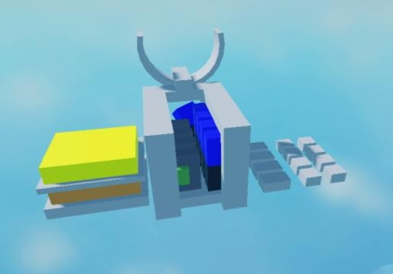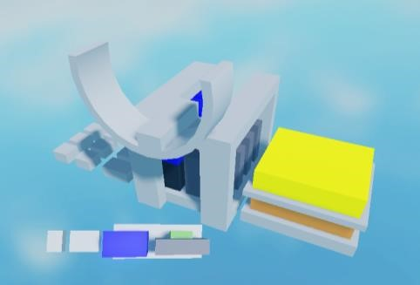

*Figure*

*4*

*Figure*

*5*

*Figure*

*6*

As seen on these layout models this is going to be the layout of the glove. The glove colours represent the following:

Orange = Arduino

Yellow = Additional Circuitry

Blue = SG90 Servos

Black = Servo gear box for clamping on the wires.

Dark Gray = Reels for the wires.

Green = Rotary Encoders.

Gray = Mounts/Finger Mounts

All of the pieces are approximately sized to their real counterparts.

**The way the haptic glove will work** is by stopping your hand movement using brakes (the black gearbox attached to the blue servos) that press onto steel 0.1mm wires that are guided through the small plastic bits attached to the fingertips with straps.

The glove will know approximately what position your fingers are in because of the rotary encoders (green) implemented into the reels (dark gray) which output a signal into the circuitry (yellow) and into the Arduino which will be set up as an addition to the oculus quest controllers.

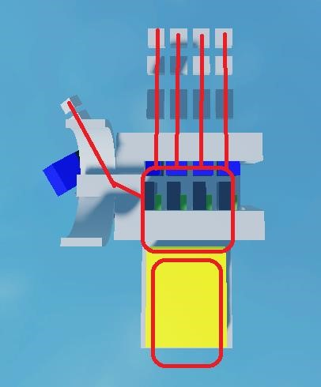

*Figure*

*7*

The picture above (Figure 7) adds a drawing rough drawing of the human hand to allow you to see how this will fit. The top peace’s will go onto the finger tips.

In the layout I account for the finger joints as I can not put too much stress on the finger joints, that is also where I will position the plastic bits that I will pull on to pull on fingers. Diagram of joins can be seen below (Figure 8). I need to allow the fingers to be naturally stopped. That is why I selected straps for the finger attachments so they can be positioned on each finger part allowing the glove to fit multiple sizes.

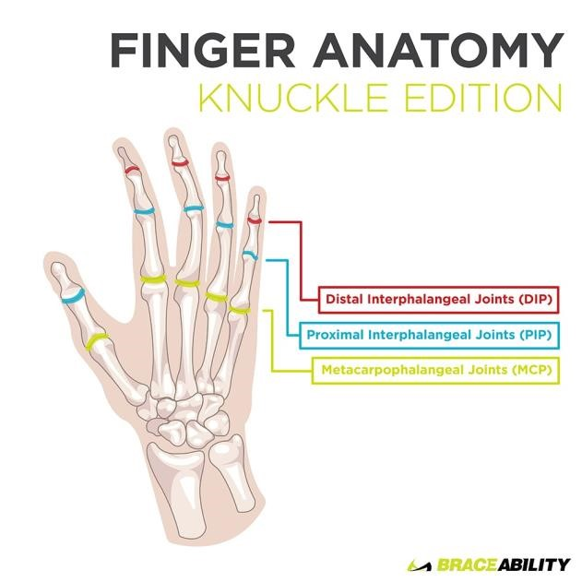

*Figure*

*8*

**Firmware**

Firmware will be located on the Arduino Uno and its primary functions is to receive sensor reading from the haptic glove module. Firmware on the Arduino Uno will interpret the information from encoders to estimate each fingers approximate position. The encoders have two outputs lets called them A and B when rotating in eather direction each pin will output one after another and they will turn off one after another. So for example if you rotate clockwise A would turn on then B would turn on then B would turn off followed by A. If you move in the other direction its essentially the same but with A and B swapped. Therefore to calculate the angle that that the finger is bent by can be done by first stretching out the finger straight and setting that angle as zero then using (360/24 * ((currentPosition - startingPosition)%24))/3 I can figure out the angle each joint will take.

Additionally, based on the collision zones of your virtual hand that are placed in the same places as your vibrating cell phone motors the Arduino will receive activation commands. The closer your fingers get to the centre of the zones the more intense the vibrations. The Arduino will be set into controller mode and I will output the information into the oculus quest headset which will receive it and send it into it’s unreal engine. Additionally, when collision of points on the virtual avatar hand happens the gearbox set up will clamp the wires with the SBR rubber pads and stop the wires consequently stopping the users fingers.

**Setting Up Test Environment**

The environment is done in the unreal engine which oculus quest uses and supports it’s developers with. There I can set up the oculus quest controllers and synch them with the haptic glove into a single controller. I also have various tools available to me (De Bonet, 2022) to take advantage of to set up my glove project in the environment. Because of the VR integration tools in the unreal engine I can easily implement the controllers.

**What is next? Work in progress?**

There are some more things that have yet to be improved on the current design of the glove such as the accuracy of finger prediction perhaps with a flex sensor including the side to side motion and thumb motion, also the ability for the glove to actually pull your fingers back is something I am working on and will likely implement a DC motor with a reverse locking mechanism and current monitoring. The ability to detect how much force the user is putting in is also useful as I can make objects deform under stress.

Then there are smaller things like how to relive stress on fingers, reduce weight, what thickness of plastic to use.

**Milestones**

**13 Nov 2021 - 7 Jan 2022 = Research**

1. Research modelling software and tutorials that would allow me to produce the exo skeletons. 13 Nov 2021 - 17 Nov 2021
2. Make exoskeleton sketches. 17 Nov 2021 - 25 Nov 2021
3. Research different materials and 3D printing. 25 Nov 2021 - 30 Nov 2021 4. Research electrical components. 25 Nov 2021 - 30 Nov 2021
4. Create a circuit layout and additional sketches. 30 Nov 2021 - 6 Dec 2021
5. Research unreal engine tutorials and articles for VR rigging/ c# programming. 6

Dec 2021 - 17 Dec 2021

1. VR world design ideas. 17 Dec 2021 - 19 Dec 2021
2. Write literature review. 19 Dec 2021 - 7 Jan 2022

**8 Jan 2022 - 31 March 2022 = Produce Product, Test, Report**

1. Create first exoskeleton model. 8 Jan 2022 - 15 Jan 2022
2. Test electronics fit. 15 Jan 2022 - 19 Jan 2022
3. Design circuit layout and connections. 19 Jan 2022 - 24 Jan
4. Edit Model / Print test exo model. 20 Jan 2022 - 31 Jan 2022
5. Apply parts onto the exo model/program. 1 Feb 2022 - 11 Feb 2022
6. Test eco model and electronic component basic functionality. 11 Feb 2022 - 13 Feb 2022
7. Adjust exo design. 14 Feb 2022 - 16 Feb 2022
8. 3D print new design. 16 Feb 2022 - 20 Feb 2022
9. Apply electronic components/program. 21 Feb 2022 - 27 Feb 2022
10. Test 28 Feb
11. Final adjustments. 1 Mar 2022 - 6 Mar 2022
12. Create a test world in unreal and rig it for basic VR. 7 Mar 2022 - 9 Mar 2022
13. Connect the world to the glove. 10 Mar 2022 - 13 Mar 2022
14. Create the test environment. 14 Mar 2022- 20 Mar 2022
15. Testing with focus group to meet objectives. 21 Mar 2022 - 23 Mar 2022
16. Report 23 Mar 2022 - 31 Mar 2022

# Final Report

The project is complete. This is the review of what the project has ended up being and what the project has achieved.

The haptic glove ended up being created from MDF board and is not as smooth as expected it works to some degree where I was able to measure recognise the finger bending and was able to rotate servos to limit movement. Each finger has a pulley construction with a servo to limit the rotation of the spring loaded pulley, all of this is mounted on a work glove. For ease of construction each structure for each board was mounted on a plate to add rigidity. When the pulley rotates it’s cog rotates an encoders cog allowing me to get a reading on the movement. However due to the fact that steps take some degree of force and the springs being a little too weak the mechanism is not very smooth.

In addition to that while theoretically you could mount the controller with the rubber bands that did not go too well as it kept falling off. I would need a new controller holder in order to be able to move the hand virtually.

Currently the glove was only able to limit finger movement and measure steps that your finger would take when you extend it. Which is possible to connect to the environment with more work and improvements to the sturdiness of the design.

I was able to set up the environments thanks to many of the dev libraries and a bunch of tweaking.

Below you can see the final prototype.

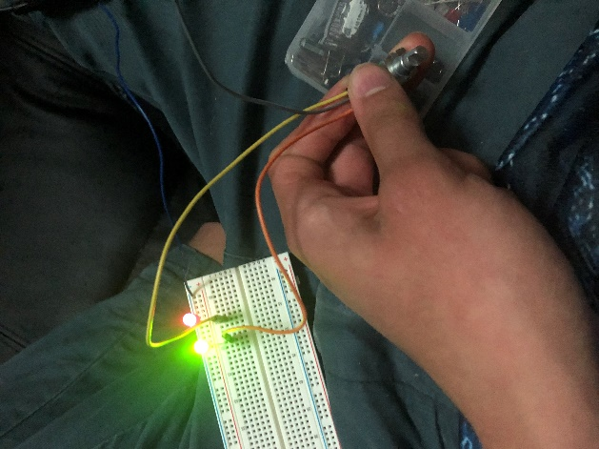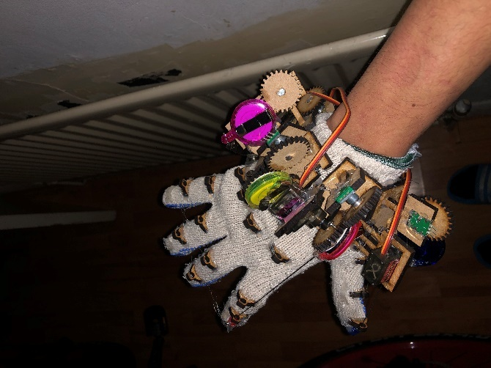In this prototype you can see all the components assembled together. It was only used to measure the rotation of the encoders.

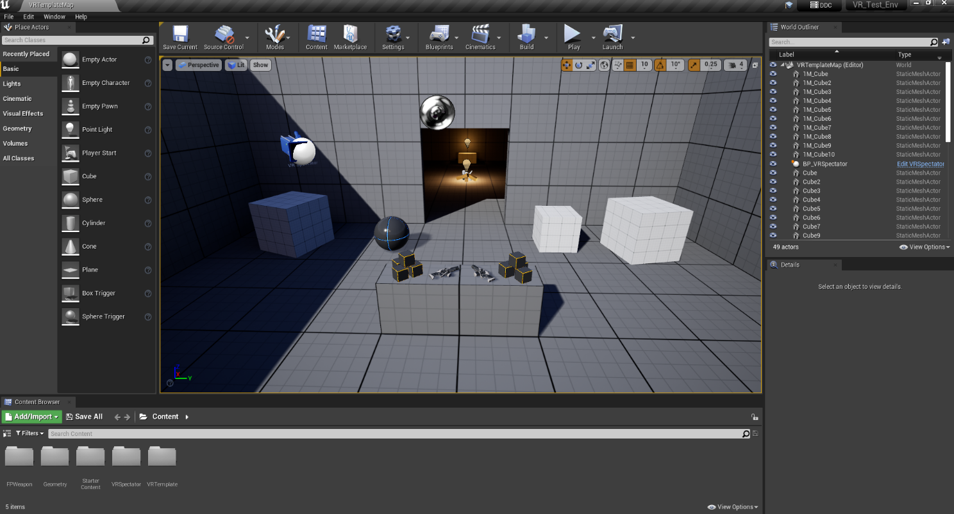

The environment was also ready for testing out the glove functionality.

**The design process adjustments**

There had to be some adjustments to the design where I now use the MDF board of 0.4mm in size. The components were made in Inkscape with references to the sizes of things like Arduino, the encoders, the reels, the glove, and the servos.

The main issue did remain however as to how to mount an Oculus Quest controller which could just be strapped with rubber bands temporarily. Additionally the glue I used and the design in general did come together but was not very sturdy so it kept falling appart.

Below you can find some sketch designs I used for the laser cutting. They are accurately measured to size.

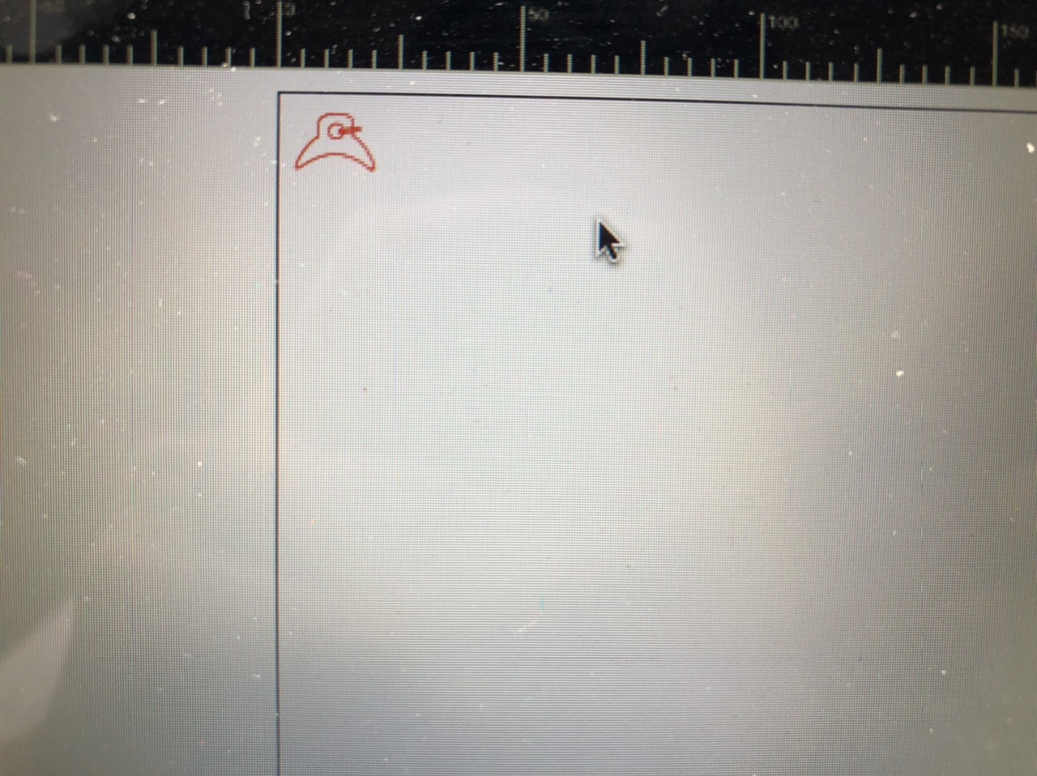

This is the finger attachment points where the cable goes. You can see these on my final picture.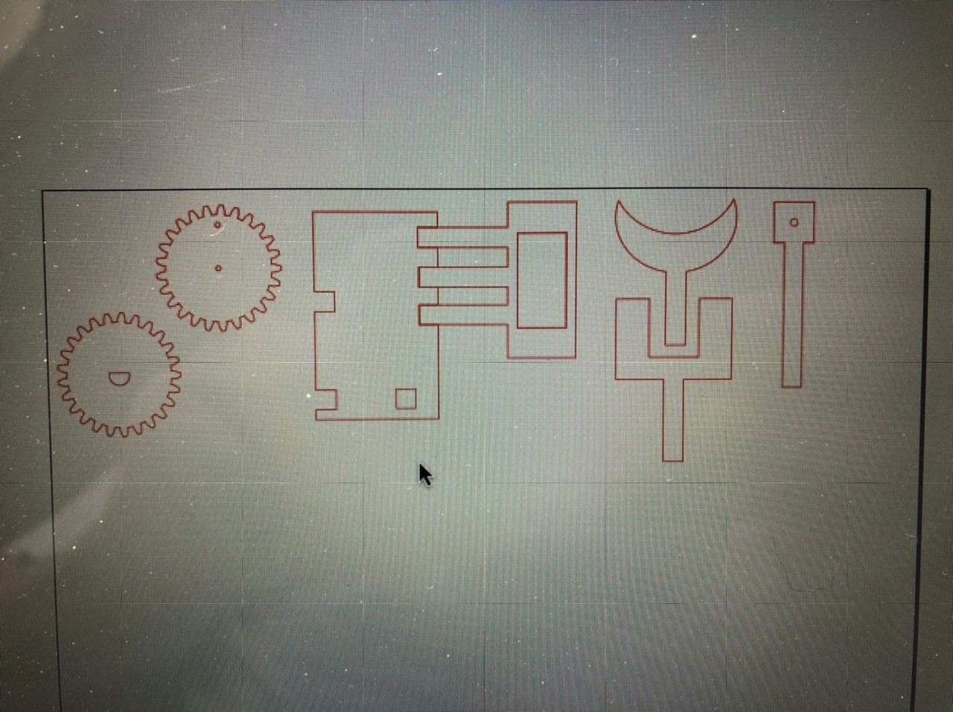

These are parts of each finger reel mechanism or to be accurate their mounts for things like servos, encoders and badge reels.



These are meant to be the mounting plates for Arduino which I ended up not using.

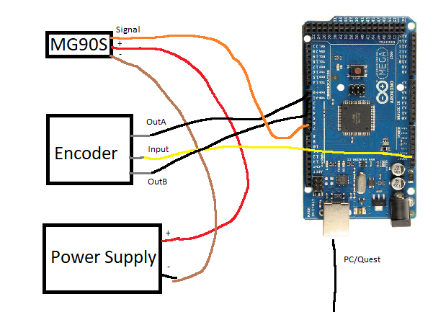

Here you can see the wiring layout I ended up using when testing the fingers (which did keep falling apart because of the glue being too weak.)

**Citations**:

De Bonet, L., 2022. I built $60 VR Haptic Gloves to feel Virtual Reality.. [online] Youtube.com. Available at: <https://www.youtube.com/watch?v=ZTzn37Usa-U> [Accessed 13 January 2022].

De Jong, N., 2021. VR Haptic Gloves for Oculus Meta Quest 2 are HERE!. [online] Youtube.com. Available at: <https://www.youtube.com/watch?v=EXqQlQmcGlY&t=480s> [Accessed 13 January 2022].

Hosseini, M., Sengül, A., Pane, Y., De Schutter, J. and Bruyninck, H., 2018. ExoTenGlove: A Force-Feedback Haptic Glove Based on Twisted String Actuation System. [online] Ieeexplore.ieee.org. Available at: <https://ieeexplore.ieee.org/document/8525637> [Accessed 13 January 2022].

Nozaki, W., Koyanagi, K., Oshima, T., Matsuno, T. and Momose, N., 2007. Development of Passive Force Display Glove System and Its Improved Mechanism. [online] Ieeexplore.ieee.org. Available at: <https://ieeexplore.ieee.org/document/4303974> [Accessed 13 January 2022].

Wang, H., Zhou, Q., Liu, L., Zhao, B. and Wang, C., 2020. A Research on Virtual Training System Based on Force Feedback Data Glove. [online] Ieeexplore.ieee.org. Available at: <https://ieeexplore.ieee.org/document/9045489>.

Wood, R., 2021. Valve Index is the second most popular VR headset on Steam, and that's a huge surprise. [online] TechRadar. Available at:

<https://www.techradar.com/news/valve-index-is-the-second-most-popular-vrheadset-on-steam-and-thats-a-huge-surprise> [Accessed 12 January 2022].

Zhang, Y., Wang, D., Wang, Z., Zhang, Y. and Xiao, J., 2019. Passive Force-Feedback Gloves With Joint-Based Variable Impedance Using Layer Jamming. [online] Ieeexplore.ieee.org. Available at: <https://ieeexplore.ieee.org/document/8678855> [Accessed 13 January 2022].

Zykov, E., Shigapov, M., Kugurakova, V., 2018. Design of Digital Gloves with Feedback for VR. [online] Ieeexplore.ieee.org. Available at: <https://ieeex-

plore.ieee.org/document/8524807> [Accessed 13 January 2022].

## Research Ethics Screening Form for Students

Middlesex University is concerned with protecting the rights, health, safety, dignity, and privacy of its research participants. It is also concerned with protecting the health, safety, rights, and academic freedom of its students and with safeguarding its own reputation for conducting high quality, ethical research.

This Research Ethics Screening Form will enable students to self-assess and determine whether the research requires ethical review and approval via the Middlesex Online Research Ethics (MORE) form before commencing the study. Supervisors must approve this form after consultation with students.

|  |  |  |  |
| --- | --- | --- | --- |
| Student Name: Aleksandrs Lukjanovs | |  | Email: al1074@live.mdx.ac.uk |
|  | Research project title: Haptic Glove Project | | |
|  | Programme of study/module: Individual Project CST3990 | | |
| Supervisor Name: Dr Kelly | | Androutsopoulos | Email:  K.Androutsopoulos@mdx.ac.uk |

Please answer whether your research/study involves any of the following given below:

1. HANIMALS or animal parts. No

Yes

1. MCELL LINES (established and commercially available cells - biological research). NoYes
2. HCELL CULTURE (Primary: from animal/human cells- biological research). NoYes
3. HCLINICAL Audits or Assessments (e.g. in medical settings). No

Yes

|  |  |  |  |  |  |  |
| --- | --- | --- | --- | --- | --- | --- |
| 5. XCONFLICT of INTEREST or lack of IMPARTIALITY.  If unsure see “Code of Practice for Research” (Sec 3.5) at: https://unihub.mdx.ac.uk/study/spotlights/types/research-at-middlesex/research-ethics | Yes | |  | No | | |
| 6. XDATA to be used that is not freely available (e.g. secondary data needing permission for access or use). |  |  |  | No | | |
| Yes |
| 7. XDAMAGE (e.g., to precious artefacts or to the environment) or present a significant risk to society). |  |  |  | No | | |
| Yes |
| 8. XEXTERNAL ORGANISATION – research carried out within an external organisation or your reseach is commissioned by a government (or government body). |  |  |  | No | | |
| Yes |
| 9. MFIELDWORK (e.g biological research, ethnography studies). |  |  |  | No | | |
| Yes |
| 10. HGENETICALLTY MODIFIED ORGANISMS (GMOs) (biological research). |  |  |  | No | | |
| Yes |
| 11. HGENE THERAPY including DNA sequenced data (biological research). |  |  |  | No | | |
| Yes |
| 12. MHUMAN PARTICIPANTS – ANONYMOUS Questionnaires (participants not identified or identifiable). | Yes | |  |  |  |  |
| No |
| 13. XHUMAN PARTICIPANTS – IDENTIFIABLE (participants are identified or can be identified): survey questionnaire/ INTERVIEWS / focus groups / experiments / observation studies. | Yes | |  | No | | |
| 14. HHUMAN TISSUE (e.g., human relevant material, e.g., blood, saliva, urine, breast milk, faecal material). | Yes | |  | No | | |
| 15. HILLEGAL/HARMFUL activities research (e.g., development of technology intended to be used in an illegal/harmful context or to breach security systems, searching the internet for information on highly sensitive topics such as child and extreme pornography, terrorism, use of the DARK WEB, research harmful to national security). | Yes | |  | No | | |
| 16. XPERMISSION is required to access premises or research participants. |  |  |  | No | | |
| Yes |
| 17. XPERSONAL DATA PROCESSING (Any activity with data that can directly or indirectly identify a living person). For example data gathered from interviews, databases, digital devices such as mobile phones, social media or internet platforms or apps with or without individuals'/owners' knowledge or consent, and/or could lead to individuals/owners being IDENTIFIED or SPECIAL CATEGORY DATA (GDPR) or CRIMINAL OFFENCE DATA. | Yes | |  | No | | |
| XPUBLIC WORKS DOCTORATES: Evidence of permission is required for use of works/artifacts (that are protected by Intellectual Property (IP) rights, e.g. copyright, design right) in a doctoral critical commentary when the IP in the work/artifact is jointly prepared/produced or is owned by another body | Yes | |  | No | | |
| 18. HRISK OF PHYSICAL OR PSYCHOLOGICAL HARM (e.g., TRAVEL to dangerous places in your own country or in a foreign country (see [https://www.gov.uk/foreignhttps://www.gov.uk/foreign-travel-advicetravel-advice)](https://www.gov.uk/foreign-travel-advice), research with NGOs/humanitarian groups in conflict/dangerous zones, development of technology/agent/chemical that may be harmful to others, any other foreseeable dangerous risks). | Yes | |  | No | | |
| 19. XSECURITY CLEARANCE – required for research. |  |  |  | No | | |
| Yes |
| 20. XSENSITIVE TOPICS (e.g., anything deeply personal and distressing, taboo, intrusive, stigmatising, sexual in nature, potentially dangerous, etc). |  |  |  | No | | |
| Yes |

M – Minimal Risk; X – More than Minimal Risk. H – High Risk

If you have answered 'Yes' to ANY of the above questions, your application REQUIRES ethical review and approval using the MOREform **BEFORE commencing your research**. Please apply for approval using the MOREform [(https://moreform.mdx.ac.uk/)](https://moreform.mdx.ac.uk/). Further guidance on making an application using the MOREform can be found at: [www.tiny.cc/mdx-ethics.](http://www.tiny.cc/mdx-ethics)

If you have answered 'No' to ALL of the above questions, your application is Low Risk and you may NOT require ethical review and approval using the MOREform before commencing your research. Your research supervisor will confirm this below.

Student Signature:Lu*k*janovs Date: 11 January 2022

**To be completed by the supervisor:**

|  |  |
| --- | --- |
| Based on the details provided in the self-assesment form, I confirm that: | Insert Y or N |
| The study is Low Risk and does not require ethical review & approval using the MOREform |  |
| The study requires ethical review and approval using the MOREform. | Y |

Superivsor Signature:  Date: 11 January 2022